APPLICANT FORMAT FOR PATENT APPLICATION

Sr. No | Name of Applicants | Email ID | Phone No. | Gender  M/F | Address | District & State | Pin code | Signature
1. | ADITYA SINGH RAJPUT | adityarajsir162@gmail.com | 9424831233 | M | Housing board colony narsinghpur  487001 | NARSINGHPUR,  MADHYA PRADESH | 487001 | 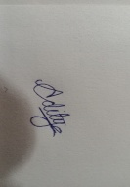
2. | AKSH USRATHE | akshusrathe007@gmail.com | 9399765924 | M | 781, Garha Bajar, Near Ramlila Ground, Garha, Jabalpur | JABALPUR,  MADHYA PRADESH | 482002 | 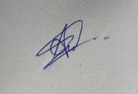
3. | PRANAV NAMDEO | pranav.namdeo18@gmail.com | 9755967700 | M | 632, Shankar Ghee Bhandar, Gadha Phatak, Jabalpur | JABALPUR,  MADHYA PRADESH | 482002 | 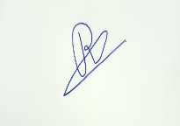

Name & Communication Address :
